00

Intacct User Guide
Archdiocese of Indianapolis
A guide containing procedures, FAQs, and best practice recommendations for Intacct, the accounting system used by the Archdiocese of Indianapolis.

Table of Contents
Resources 2
Intacct User Guide (this document) 2
Intacct Help Section on Website 2
Contact OAS with Intacct questions 2
User Access 2
How to Log In 2
Forgot your password? 3
Accounts Payable and Purchasing 3
Overview and AP Processing Timeline 3
Payment Roadmap 4
Process Flow Diagram 5
Vendors – General Information 6
Instructions: How to Request a New Vendor 7
Instructions: How to Request a Vendor Address Change 7
Instructions: How to fill out a Payment Requisition and Submit for Approval 7
FAQ: Can I see payment requisitions submitted by other users? What if I’m new and am coding a payment requisition for the first time? 13
Instructions: How to Review and Approve or Decline a Payment Requisition 14
Payment Requisition Status/State Definitions 16
Purchasing Transaction Definitions 17
General Topics and Information 18
Wildcard Search 18
Attachments and Supporting Documentation 19
Dimension Values and Rules/Relationships 20
Dimension Values Listing 20
Location (entities) 20
Program 20
Account 21
Restriction 21
Project_Grant 22
Activity 22
Reporting and Dashboards 22
Dashboards Overview 22
Financial Report Terminology 23
Accessing the Dashboards Module 23
Dashboard Filters 24
Drilling Down on Reports 25
Exporting Reports to Excel 28
General Ledger Report 30
Accounting Policies 33

Resources

Intacct User Guide (this document)

Intacct Help Section on Website
- See screen shot below for how to access the Intacct self-help section on the Intacct website. By clicking ‘Help on this page’, Intacct will automatically direct you to the help that is applicable to the page that you are currently on.
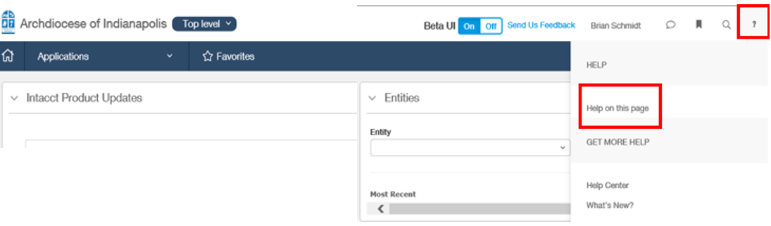

Contact OAS with Intacct questions
  - In person: Catholic Center, Room 209
  - E-mail: accountingservices@archindy.org
  - Phone: 317-236-1410
  - Business Hours: Monday – Thursday, 8:00 AM – 5:30 PM EST

User Access

How to Log In
  - Website www.intacct.com
  - You can access Intacct.com from any computer, tablet, or mobile device with an internet connection.
  - URL you can use to pre-populate the company ID and user ID on the Intacct login screen: https://www.intacct.com/ia/acct/login.phtml?.company=Archindy&.login=youruseridhere (be sure to replace “youruseridhere” with your actual user ID (e.g. JMerrick). Then just bookmark the website.
  - Company ID = Archindy (case-sensitive)
  - Username (case-sensitive)
  - Password (case-sensitive)
  - 2-Factor Authentication – see ‘Intacct 2-Factor Authentication Instructions’ document for additional instructions.
  - When logging into Intacct for the first time, select ‘Enable Beta UI’ (UI = Interface) in top right corner. This will activate the new beta Intacct interface, which will eventually become the new standard interface. Again, this only needs to be done the first time you log in to Intacct.
  - When using Intacct, always remain logged in at the ‘Top Level’. System functionality WILL NOT WORK if you enter a specific location. If your screen says anything other than ‘Top Level’, please contact us at accountingservices@archindy.org.
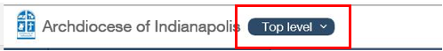

Forgot your password?
  - You are allowed 5 attempts to correctly enter your password.
  - After 4 incorrect attempts to enter your password, please do not attempt to enter your password a fifth time. Use the ‘Forgot your password?’ link on the login page to reset your password to avoid being locked out.
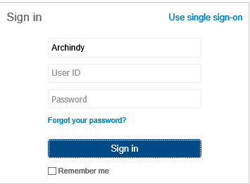
  - After 5 incorrect attempts to enter your password, you will be locked out of the website. The only way to unlock your account is to contact accountingservices@archindy.org and have a member of the OAS team unlock it for you during business hours.

Accounts Payable and Purchasing

Overview and AP Processing Timeline
  - The Archdiocese has a centralized Accounts Payable function that processes payments for multiple entities. A “Payment Roadmap” exists to help employees know which process to follow when requesting a payment. Payments enter the queue for processing once the Intacct Payment Requisition has been approved. Standard processing time for issuing a payment is 3 business days from the day it is approved; however, we hope to be able to process payments even more quickly as time goes on.

Payment Roadmap

Common Payment Types | Process for Requesting a Payment | Method of Payment | Notes
Vendor payments for non-Charities locations | Intacct Purchasing Module - Payment Requisition | Check or ACH
Vendor payments for Charities locations | Intacct Purchasing Module - Payment Requisition Charities | Check or ACH
Vendor payments for CYO | Intacct Purchasing Module - Payment Requisition CYO | Check of ACH
Expense Reimbursements | Paylocity Web Expense Module (preferred) | Payroll ACH
 | Petty Cash Disbursement Request Form (Max expense = $25)  http://www.archindy.org/finance/intacct.html  Completed form should be submitted to Sandi Jackson in OAS and used in urgent cases only. | Cash | If form is delivered before noon, cash will be available by EOB; otherwise, cash will be available by noon the following business day.
Petty cash replenishment | Intacct Purchasing Module - Payment Requisition | Check
Employee Stipend Requests (Non-Mass) | Employee Stipend Request Form http://www.archindy.org/finance/intacct.html | Payroll ACH | Additonal steps taken by OAS to reimburse location for the payroll expense when applicable.
Fifth Third Credit Card (for cardholders) | Excel spreadsheet provided by Valorie Curran | Auto-draft (EFT)
Refugee Direct Assistance Payments | Intacct Purchasing Module - Payment Requisition Charities | Check | Include case # and refugee policy statement for direct assistance payments
Senior Companion Stipends | AP Bills Import Template | Check
Checks written out of agency program checking accounts | Intacct Purchasing Module - Payment Requisition Charities | None - the check has already been written, but this will record it | Indicate the program (HFS, Crisis, SEC, etc.) and the Check # in the Vendor Document Number field. E.g. Crisis Check #2891 in the Vendor Document Field. See User Guide for instructions.
Utilities on autopay | Intacct Purchasing Module - Payment Requisition | Auto-draft (EFT) | Select 'Record a transfer' in the Payment Requisition
Employee Benefits (paid to employees) for Adoption Reimbursement or Catholic School Tuition Reimbursement | Employee Stipend Request Form http://www.archindy.org/finance/intacct.html | Payroll | HR fills out employee stipend request form. Additonal steps taken to reimburse location for the payroll expense when applicable.
Priest healthcare reimbursements (when priest pays medical cost out of pocket) | Expense Reimbursement Request Form | Payroll | HR fills out expense reimbursement request form
Payments by Mission Office | Intacct Purchasing Module - Payment Requisition | Check
Payments to parishes (misc.) | Intacct Purchasing Module - Payment Requisition | ACH

Process Flow Diagram

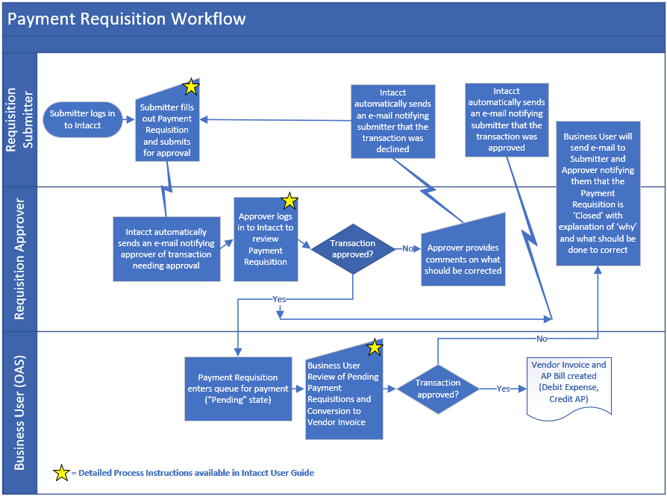

Vendors – General Information
  - Any non-employee paid by the Archdiocese should be set up as a vendor in Intacct. See below for New Vendor Request process.
  - Volunteers receiving reimbursements from the Archdiocese should be set up as vendors in Intacct so that we can track the payment recipient. Volunteer expense reimbursements with supporting documentation for the business-related expense are not taxable and would not be included on a Form 1099 at the end of the year.
  - Employees should never be set up as vendors. Employees can be paid through the following avenues:
    - Hourly wages or salary: Paid through Central Payroll based on actual hours worked, via direct deposit.
    - Stipend: Taxable earnings outside of normal hourly wage or salary (e.g. a stipend for additional services rendered), paid through Central Payroll via direct deposit. For an employee stipend, use the Employee Stipend Request Form found on the Archindy website at: http://www.archindy.org/finance/intacct.html
    - Employee Expense Reimbursement: Non-taxable reimbursement of qualified business expenses, paid through Central Payroll via direct deposit. A request for an Employee Expense Reimbursement is initiated through Paylocity’s Web Expense module. Instructions on how to complete this process can be found at: http://www.archindy.org/finance/intacct.html
  - Only one record/ID for each vendor is needed in Intacct. All entities can use the same vendor record/ID. At any point in time, we can analyze the payments made to the vendor on an individual entity basis or on a consolidated basis.
  - Preferred payment method – Vendors are set up with a blank default preferred payment method, which will result in them being paid via check. Vendors that prefer to receive payments via ACH or bank auto-draft (record a transfer) can have their default preferred payment method updated accordingly. The Preferred Payment Method field in the Vendor record is what drives the method of payment during each payables run. If a payment needs to be made differently than the default payment method, please communicate the one-off change to accountingservices@archindy.org.
  - We have set up each of the Archdiocesan parishes, high schools, and agencies as Vendors, with the final 3 digits of the Vendor ID corresponding to the 3 digit Archdiocese Parish Number. Default Payment Method for Arch locations is ACH.

Instructions: How to Request a New Vendor
  - If you are using a new vendor, e-mail the following information to accountingservices@archindy.org
    - Vendor Name
    - Vendor Address, City, State, ZIP
    - Preferred Payment Method (Check or ACH). If ACH, please instruct the vendor to complete the Vendor ACH Payment Authorization Form: http://www.archindy.org/finance/files/ACH%20Payment%20Authorization%20Form.pdf . The ACH Payment Authorization Forms should be uploaded by the vendor through the secure portal at: https://www.archindy.org/finance/ach.html . Once the Vendor ACH Payment Authorization Form has been uploaded by the vendor, OAS will perform due diligence procedures to validate the vendor banking information.
    - W-9 filled out and signed by the vendor. This is required for all vendors. A blank W-9 can be found on the IRS website.
  - Save your Payment Requisition in ‘Draft’ status until we e-mail you back to let you know that the vendor has been created. After you hear back from OAS that the vendor has been created, all you will need to do is enter the vendor name into the Payment Requisition and click ‘Submit’.
  - OAS Recommend Practice: To avoid delays in processing, we recommend creating the vendor in Intacct at the inception of the business relationship. That way, the vendor ID already exists in Intacct when you receive your invoice and are ready to prepare your Payment Requisition.
    - Example #1: If you contract with a vendor to provide a service, ask them for their W-9 at the time you request the service and send the New Vendor Request e-mail to accountingservices@archindy.org at that time.
    - Example #2: If you order materials for an upcoming event, request the vendor’s W-9 at the time you place the order and send the New Vendor Request e-mail to accountingservices@archindy.org at that time.

Instructions: How to Request a Vendor Address Change
  - If the vendor’s pay-to address has changed, e-mail accountingservices@archindy.org to notify us of the change in the address so we can update the Vendor profile in Intacct. Do NOT create a new vendor just because the address changed.
  - Save your Payment Requisition in ‘Draft’ status until we tell you that the update has been made. After you hear back from OAS, all you will need to do is enter the vendor name into the Payment Requisition and click ‘Submit’.

Instructions: How to fill out a Payment Requisition and Submit for Approval
  - Select ‘Applications’ from the top left corner of your screen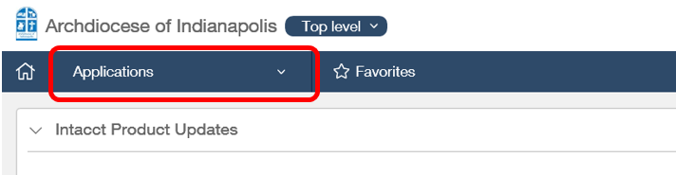
  - Select ‘Purchasing’ from the drop-down menu that opens up.
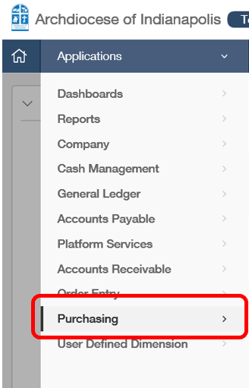
  - Select the + sign to the left of the ‘Payment Requisition’ transaction definition you want to use. Clicking on the + will create a new Payment Requisition. Clicking on the hyperlink for ‘Payment Requisition’ will take you to a list view of Payment Requisitions.
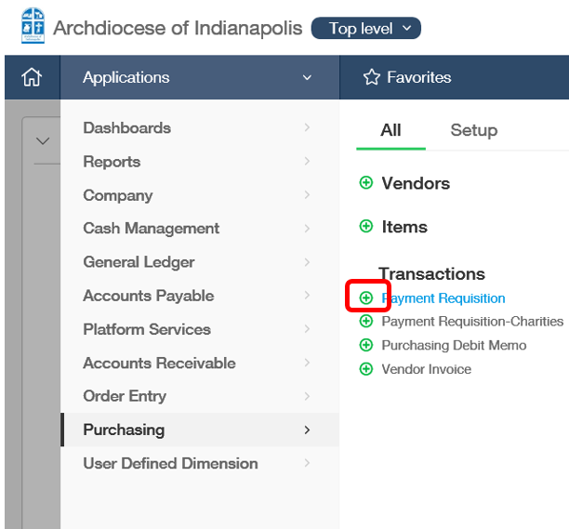
  - Header-level Information: On this portion of the screen, you’ll enter header information for the vendor and invoice.

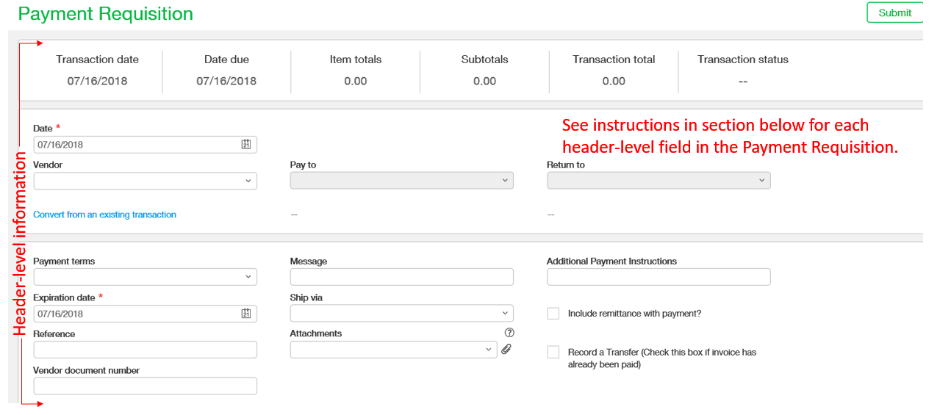
    - Date – Leave as the current date (not the invoice date or due date). This field auto-populates to the current date. This date field does not impact anything in the payables process, as OAS will enter the invoice date, due date, and GL posting date when the Payment Requisition is converted to a Vendor Invoice.
    - Vendor – Type in the vendor name or the vendor ID. As you start typing, the listing of vendors will automatically filter down based on what has been typed so far. This automatic filtering is based on what you’ve typed matching the beginning of the vendor name. For example, typing ‘Offic’ into the Vendor field would give you Office 360, Office of Catholic Schools, but would not give you CCFM National Office because CCFM National Office does not begin with ‘Offic’. A wildcard search will allow you to search for any vendors that contain ‘Offic’ anywhere in the vendor name.
      - Wildcard Search: To do a wildcard search, see instructions here.
      - Is your vendor not listed? If your vendor search does not yield any results, we will need to create a new vendor in Intacct. See instructions here for new vendor requests.
      - Did your vendor’s address change? Compare the vendor’s address in Intacct to the payment address on your invoice and verify that they are the same. If a vendor address must be updated, please notify OAS. See instructions here for vendor address change requests.
    - Pay to and Return to – These fields will automatically populate after you select your vendor. Do not overwrite the information in these fields. If you think you need a different ‘Pay to’ or ‘Return to’, please contact OAS.
    - Payment terms – Leave as ‘Due upon receipt’. If your invoice provides for a discount if paid within a certain period of time, enter the discounted price in the line item details if the payment is expected to be received in time to take the discount.
    - Expiration date – Disregard this field. A date will populate here based on the ‘Date’ set above and the Payment Terms. However, this field is not used for anything so do not worry about having an accurate date here.
    - Reference – Enter an overall description of the expense in this field (e.g. office supplies, materials for conference, cleaning service 7/20/17). This is a required field. What you enter here will go onto the AP Bill and can be pulled onto a general ledger report (into the Doc column of the General Ledger Report). Will also show up on the remittance details of the check stub. If your payment requisition is for an invoice that has a variety of expenses, each requiring their own specific description or identifier, then you may also use the Line-Item field for ‘Memo’ to provide a description that is unique to each line of dimension coding. See ‘Memo’ section below for additional information. No limit on character length for what will show up in general ledger reports; however, only 23 characters will print on the check remittance (e.g. GL Implementation – Fixed Fee + Variable would be abbreviated to GL Impleme...+ Variable).
    - Vendor document number – Enter the invoice number in this field. This is a required field. It is not necessary to type “Invoice #23893832”. Instead, please just provide the actual invoice number (without quotes) “23893832”. The Vendor Document Number will be printed on the remittance details of the check stub, which will allow the vendor to match our payment with their invoice. Intacct will also verify that we don’t pay the same invoice # twice to the same vendor. However, this verification does not occur until the step where OAS converts the Payment Requisition to a Vendor Invoice and AP Bill, so please be careful to check if an invoice has already been paid before submitting and/or approving the payment requisition. Limited to 20 characters.
      - If there is no invoice number, but you have a customer account number assigned to you by the vendor, you can use the account number in the Vendor Document Number field followed by the invoice date (or current date if no invoice date), separated by hyphens. For example, an invoice with no invoice number, acct #292929, and an invoice date of 7/15/2018 would use the following Vendor Document Number: 292929-07-15-18.
      - If there is no invoice number and no account number either, you can use N/A and today’s date, separated by hyphens, for the Vendor Document Number. For example, a payment that I’m requesting on 7/7/2018 that has supporting documentation that doesn’t contain an invoice number or an account number would use the following Vendor Document Number: N/A-07-07-18.
    - Message – Disregard this field, as it is not used for anything. Leave blank.
    - Ship via – Disregard this field, as it is not used for anything. Leave blank.
    - Attachments – Attach a digital copy of your invoice or other supporting documentation here. All payment requisitions require supporting documentation to be attached. The payment requisition cannot be submitted for approval unless there is an attachment. To attach supporting documentation, you can drag the file from a saved location on your computer and drop it in the attachments box.
      - Examples of sufficient supporting documentation include invoices, copies of receipts (if reimbursing a volunteer for expenses incurred by the volunteer), a letter from the organization (if a contribution), or other documentation that substantiates why we are making the payment.
      - Attachments file types can be PDF, Excel, Word, JPG/PNG images, Outlook messages, among others.
      - OAS Note: attachment requirement is accomplished using a Smart Rule
    - Additional Payment Instructions – Can include a message to Accounts Payable, such as ‘John Doe will pick up check in OAS when available’. Whatever is entered in this field carries through to the AP Bill and can be used for filtering in the Pay Bills screen. Custom field.
    - Include remittance with payment? – Check this box if your payment requires your attachment to be included with the mailed payment (checks only). If you check this box, we will print the supporting documentation that you attached to the payment requisition and include the relevant portion with the mailed payment. This is a manual step for OAS to complete, so we ask that you check this box only if it is absolutely necessary to mail a copy of the supporting documentation with the check. Custom field.
    - Record a transfer – The ‘Record a transfer’ box should be checked if a payment has already been made and you are submitting a payment requisition as a means of recording the expense in the general ledger. Examples of this include credit card bills that are auto-paid from the bank account, utility bills that are auto-paid from the bank account, etc. If you check this box, a payment will not be sent. Custom field.
  - Line-Item Information: At the bottom of the Payment Requisition page, you will enter the dimension coding for the transaction. You can enter as many lines of dimension coding as needed.
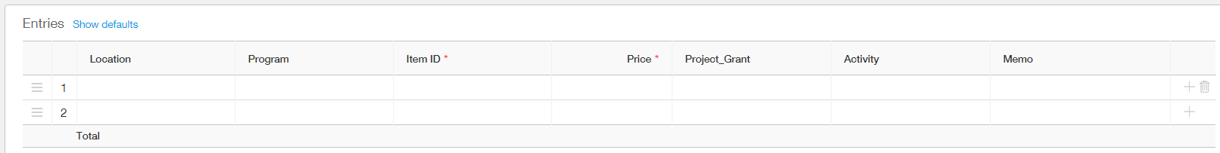
    - Location (required) – Enter your location (legal entity).
    - Program (required) – Enter the program where you want the expense to be recorded. ‘Program’ is essentially the same as ‘department’ or ‘cost center’. A full program listing can be found on the Intacct page of the Archindy.org/finance website. As you start typing, the listing of programs will automatically filter down based on what has been typed so far. This automatic filtering is based on what you’ve typed matching the beginning of the program name. For example, typing ‘Human’ into the Program field would give you Human Resources and Human Life & Dignity Office, but would not give you Catholic Campaign for Human Development because Catholic Campaign for Human Development does not begin with ‘Human’. A wildcard search will allow you to search for any programs that contain ‘Human’ anywhere in the program name.
      - Wildcard Search: To do a wildcard search, see instructions here.
    - Item ID (required) – Enter the account number where you want the expense to be recorded. Item ID = account number. A full chart of accounts, including the hierarchy of the chart of accounts, can be found on the Intacct page of the Archindy.org/finance website. As you start typing, the listing of Items/accounts will automatically filter down based on what has been typed so far. This automatic filtering is based on what you’ve typed matching the beginning of the Item/account name. For example, typing ‘Meals’ into the Item ID field would show no matching results, as there are no Items/accounts that begin with ‘Meals’. A wildcard search will allow you to search for any Items/accounts that contain ‘Meals’ anywhere in the Item/account name, which would yield a result of ‘Travel-Meals’ and ‘Room and Board – Meals/Board’.
      - Wildcard Search: To do a wildcard search, see instructions here.
      - Prepaid Expenses: Do not use 15001 Prepaid Expense when selecting your Item ID / account. Always select the expense account that your payment relates to. If your Payment Requisition is for a cost that will be incurred in a future period OAS will ensure that your expense is recorded in the proper period.
        - Example #1: If you are paying $100 in June 2017 for an October 2017 event registration, use the Conference/Meeting Registration Expense account in your Payment Requisition. Your $100 expense will be reflected in your October 2017 monthly results, and there will be no budget impact in June 2017.
        - Example #2: If you are paying $12,000 in November 2017 for an annual service contract running from January 2018 through December 2018, use the appropriate expense account in your Payment Requisition. You will see a $1,000 expense reflected in each of Jan, Feb, March, April…etc…December 2018, totaling $12,000.
    - Price (required) – Enter the amount to be charged to the particular Location (entity), Program, and Account (Item ID). The total price should be equal to the amount you wish to pay (invoice amount).
    - Project_Grant (optional, if applicable) – If your expenditure is related to a particular project or grant, identify the Project_Grant here. If your project or grant does not show up in the list of available Project_Grant options, please contact OAS. If your expenditure is not related to a project or grant, leave this field blank.
    - Activity (optional, if applicable) – The Activity dimension is for tracking sports and extracurricular activities. The Activity dimension should be used primarily by CYO, CYO Camp, and MTCA. For most users, this field should be left blank.
    - Memo (optional) – The memo field can be used for a unique description of each line of the payment requisition. The memo line will pull in to the General Ledger report as part of the Memo/Description column (see below), and will be combined on the General Ledger Report with the word “Bill” and the Vendor Name. Please use the ‘Reference’ field in the header-level information for providing an overall description of the expense, and the ‘Memo’ field in the line item information for providing a unique description of the expense when necessary. The Memo field also shows up on the detailed check remittance stub (including multiple lines if there is more than 1 line entry to the transaction). Note: there is no limit to the length of the description entered into the ‘Memo’ field.
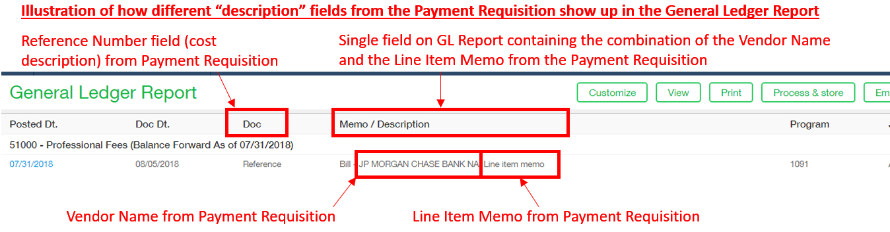
  - Once all Header-Level and Line-Item information has been entered into the Payment Requisition, click ‘Submit’ in the top-right corner of the screen. When you click ‘Submit’, an e-mail will be sent to your Manager notifying them that a Payment Requisition awaits their approval. This marks the conclusion of this step in the process.
  - Below is an image of a sample check along with a mapping of the fields from the Payment Requisition.
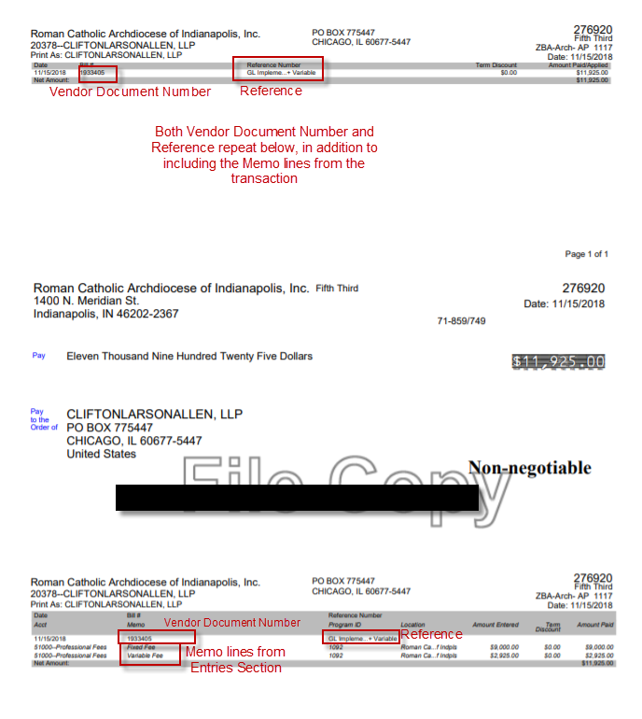

FAQ: Can I see payment requisitions submitted by other users? What if I’m new and am coding a payment requisition for the first time?

  - Payment Requisitions are workflows that are only visible to the user submitting the payment requisition and the user approving the payment requisition. Therefore, you won’t be able to see payment requisitions previously submitted and approved by other users.
  - Payment Requisitions turn into Accounts Payable Bills. You CAN see all Accounts Payable bills coded to the programs you have access to, for all of history (dating back to 7/1/18 when we began using Intacct). Even if you weren’t part of the payment requisition workflow. See screen shot below for how to navigate to list of Accounts Payable Bills. 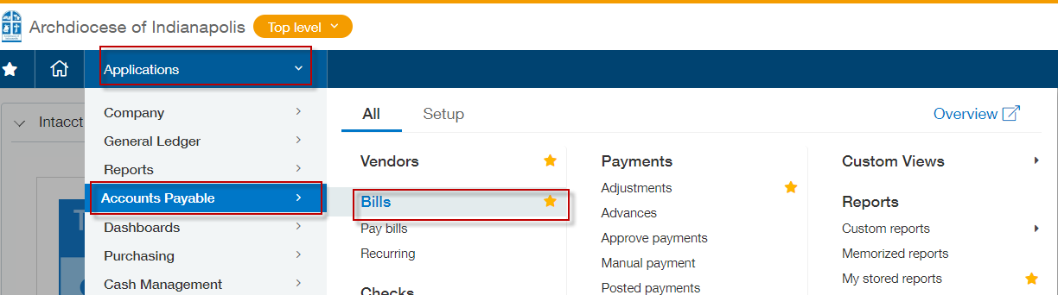
  - If you have an invoice from Office 360 and want to know how that was previously coded, check the list of Accounts Payable Bills and you can find all invoices associated with Office 360.
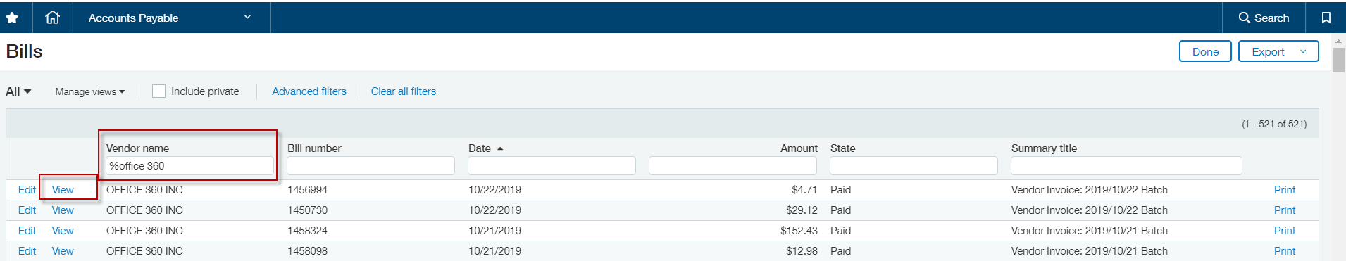
  - OAS Recommended Practice: Open 2 tabs of Intacct, one showing the Accounts Payable Bill and one with a new Payment Requisition. This way, you can flip back and forth between the tabs as you fill out a new Payment Requisition for the first time while referring to how invoices with the same vendor have been previously coded. To have multiple tabs of Intacct open at the same time, right click on the top of the Chrome tab and then click ‘Duplicate’, which will open a new tab.
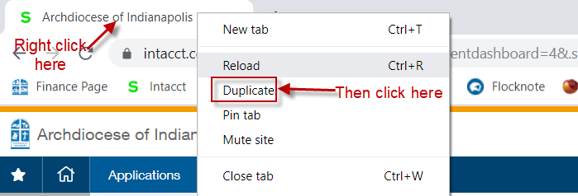

Instructions: How to Review and Approve or Decline a Payment Requisition
  - There are two ways to connect to a Payment Requisition that requires approval. The first is by following the same steps as in the ‘Initiate Payment Requisition’, except to click ‘Approve Transactions’.
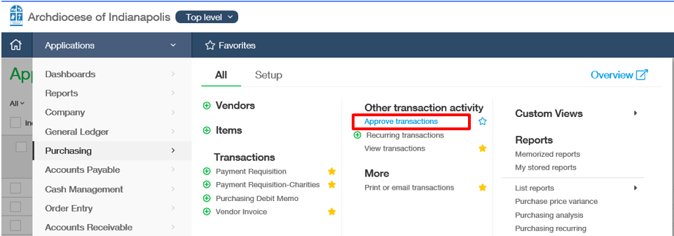
The second is by clicking the link in the e-mail (see screen shot of e-mail below).
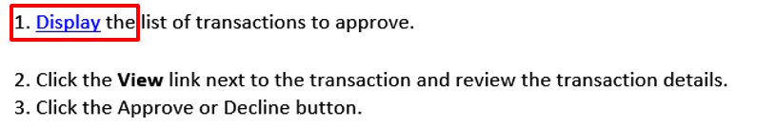
  - Either approach will take you to a list screen of transactions awaiting your approval. From this screen, you should click on the link to ‘View’ the Payment Requisition.
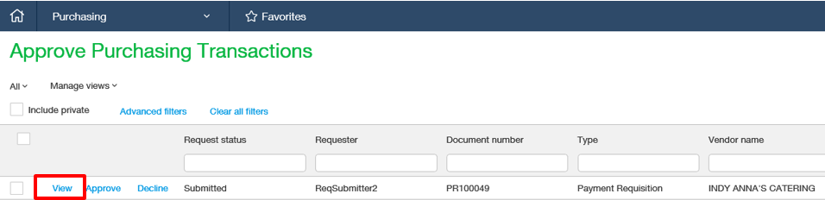
  - Your next screen will show you the details for the Payment Requisition. In all cases, you should open the supporting document that is attached to Payment Requisition. Open the attachment by clicking on the paperclip icon, which will open the attachment in a separate window.
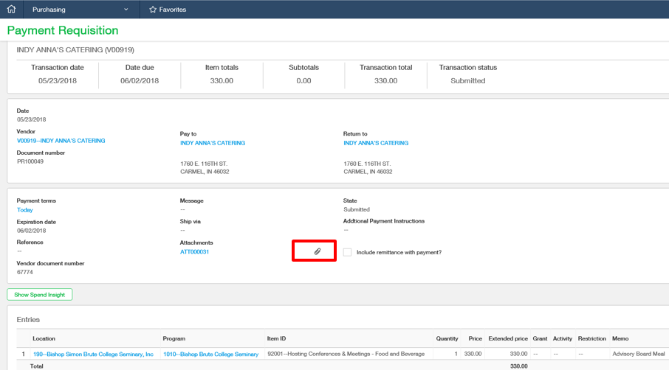
  - Your review should consist of the following:
    - Compare the information on the attachment (should be an invoice or other supporting documentation) with the information that has been entered in the Payment Requisition. This includes Vendor (name and correct address), Vendor Document Number (invoice number), Extended Price (amount to pay)
    - Verify that there is a description of the expense in the ‘Reference’ field. This field should not be blank. If this field is blank or the description is inaccurate, decline the Payment Requisition (see instructions below for declining a Payment Requisition).
    - Review the dimension coding for Location (entity), Program, Item ID (account), and if applicable, Project_Grant and Activity.
  - If you conclude that the Payment Requisition has been properly completed, click ‘Approve’ in the top right corner of the page. After a Payment Requisition is approved by the manager, the submitter of the Payment Requisition will receive an e-mail notifying them that the Payment Requisition has been approved. Now, OAS will enter the process and convert the Payment Requisition to a Vendor Invoice which generates an AP Bill.
  - If there are changes that need to be made to the Payment Requisition, the approver should ‘Decline’ the Payment Requisition. For example, an incorrect amount (invoice was for $330 but the Payment Requisition was only $33), incorrect Vendor, incorrect Vendor Document Number (invoice #), incorrect Location, Program, or Item ID. Clicking ‘Decline’ will send the Payment Requisition back to the original submitter so they have an opportunity to make necessary changes. When the Payment Requisition is Declined, the Approver has the option to leave a comment explaining what needs to be changed (see screen print below). Click ‘Decline’ at the bottom once an explanation has been provided.
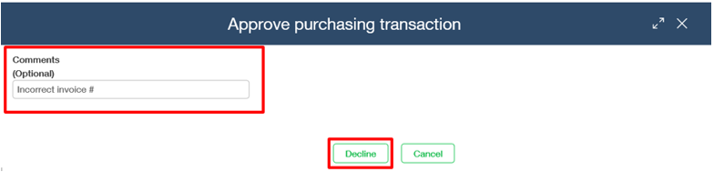
  - After declining a Payment Requisition, the original submitter will receive an e-mail notifying them that the Payment Requisition has been declined. At this point, the original submitter can make changes to the Payment Requisition and re-submit it for approval. If a Payment Requisition is declined, a new “replacement” Payment Requisition should not be created. The declined Payment Requisition should be revised and re-submitted.

Payment Requisition Status/State Definitions
  - Users can go to the List View for Payment Requisitions (or Payment Requisitions – Charities or Payment Requisition-CYO) to see each Payment Requisition they are involved with and its ‘state.’
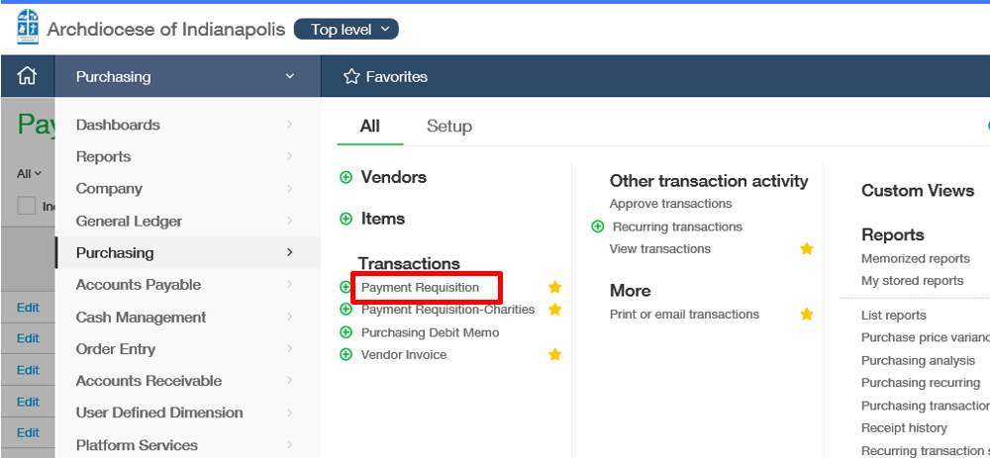
  - Definitions of the various ‘States’ for Payment Requisitions
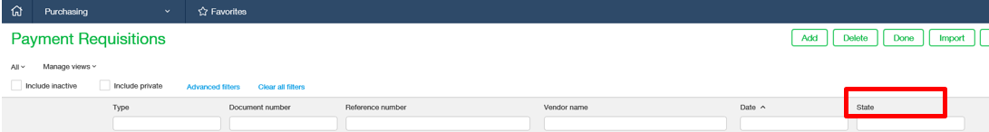
    - Draft – Payment Requisition has been created and saved as a draft, but has not been submitted for manager approval
    - Submitted – Payment Requisition has been submitted and is awaiting manager approval
    - Pending – Payment Requisition has been approved by the employee’s manager and is waiting on OAS to convert the Payment Requisition to a Vendor Invoice
    - Converted – An approved Payment Requisition has been converted to a Vendor Invoice by OAS, which generates an AP Bill (at this stage, a credit to Accounts Payable is posted and a debit to the designated expense account is also posted)
    - Declined – Payment Requisition has been declined by the approver (not by OAS) – a “Declined” transaction should go back to the original transaction submitter for revision.
    - Closed – Payment Requisition is declined permanently (perhaps it was a duplicate or an incorrect submission to begin with, with no corrective step). A “Closed” status is essentially the same as “Deleted”, except as it relates to entities that are new adopters of Intacct (historical payment requisitions carry a ‘closed’ status).

Purchasing Transaction Definitions
  - Transaction Definitions allow us to create different workflows within the Purchasing module. Each Transaction Definition has an Approval Policy assigned to it, which is what controls the approval workflow.
    - Payment Requisition – Employee manager approval, Sandi Jackson is responsible for converting Payment Requisitions to Vendor Invoices. All users have access to this transaction definition.
    - Payment Requisition Charities – Employee manager approval, Sandi Jackson is responsible for converting Payment Requisitions to Vendor Invoices. All users have access to this transaction definition.
    - Payment Requisition CYO – Employee manager approval, Kris Becher is responsible for converting Payment Requisitions to Vendor Invoices. All users have access to this transaction definition.
    - Payment Requisition Payroll – No approval. Melinda Buckler or Liz Davis generate requisition, Carey Kendall is responsible for converting Payment Requisitions to Vendor Invoices. To be used for payroll-related items such as HSA Prefund. Modified to remove requirement for attachment (to allow for uploading of high volume of common transactions). Private.
    - Payment Requisition Treasury – No approval. Nancy Miller or Diane Sutton generate requisition, Chris Bramble is responsible for converting Payment Requisitions to Vendor Invoices. To be used for ADLF withdrawals and various ACH payments initiated by Diane (or to record a transfer for auto-paid invoices). Modified to remove requirement for attachment (to allow for uploading of high volume of common transactions). Private.
    - Payment Requisition NDAA – Transaction Location Approval. Each principal is set up as the Location Manager for their respective school. Private.
    - Payment Requisition-BBurkert – Brian Burkert is the approver. All operating loan requests must be submitted through this transaction definition. A Smart Event exists to notify several other users whenever an operating loan has been requested. Private.
    - Various Payment Requisitions for Employees with Multiple Approvers (Private, access limited to the preparer, approver, and members of OAS)
      - BEichorn - Brie Ann Eichorn as secondary approver used by Keri Carroll
      - BStumpf – Msgr. William Stumpf as secondary approver used by Cathy Mayer
      - DBethuram - David Bethuram as a secondary approver used by Theresa Brydon as well as various charities employees who don’t have David as their direct supervisor/approver
      - GRoss – Gabriela Ross as a secondary approver used by Keri Carroll
      - JFeltz – Fr. Eric Johnson as secondary approver (used to be for Fr. Joe Feltz, but can’t rename the transaction definition used by Andy Miller
      - MLentz – Mickey Lentz as a secondary approver used by Theresa Brydon
      - Peggy O - Peggy O’Connor Campbell as a secondary approver used by Susan Burris
      - SWilliams – Kelly James as a secondary approver used by Maureen Okerson

General Topics and Information

Wildcard Search
- Wildcard search using % in front of the word (with no space in between). For example, %offic.
- To do a wildcard search, perform the following steps:
    - Click the drop-down arrow on the right hand side of a field (vendor, location, program, Item ID/account, project_grant, activity, among others).
    - Click ‘Find’
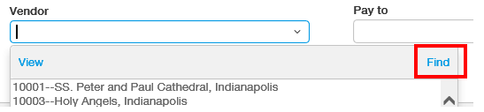
    - In the Vendor field, type a % sign followed by the characters (letters/numbers/symbols) you wish to search for. Then hit ENTER on your keyboard.
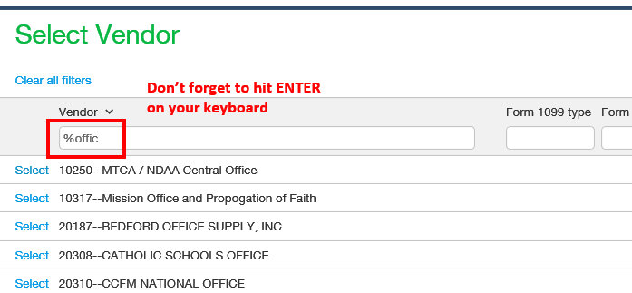
    - If you do a wildcard search, hit enter, and nothing changes on your screen (i.e. you still have the full list of vendors/programs/accounts/etc.), that means that your wildcard search did not find a match in the listing of values. Try a different search.
    - Wildcard search tip: Start your wildcard search small (e.g. %off instead of %offic if looking for ‘CCFM National Office’, and then refine by adding more characters to your wildcard search if the initial search returns too many results.

Attachments and Supporting Documentation
  - Certain transaction types, such as journal entries and payment requisitions, require an attachment before they can be submitted for approval or posted. All supporting documentation will be retained in Intacct, and no paper records will need to be kept.
  - The word ‘Attachment’ refers to the Intacct record ID. A single Attachment can contain multiple files.
  - The easiest way to add an attachment to a transaction is to drag and drop one or more files. Drag the file(s) from its source location on your computer and release your cursor when it is over the ‘Attachments’ box. This can be done for multiple files. Clicking the paperclip will allow you to see all files included in the single attachment.
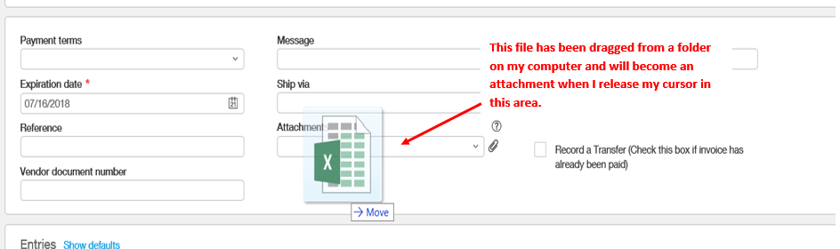
  - Attachments can also be dragged from an e-mail directly to the Intacct screen.
  - Another method for adding an attachment is to look up the source location by clicking ‘Add’ on the Attachments drop-down. This is the least efficient way to add attachments.
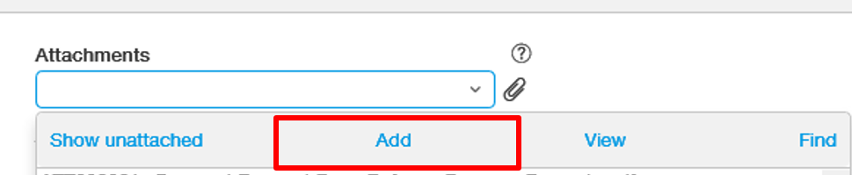
  - Attachments can be any file type (PDF, Word, Excel, Outlook E-mail Message .msg, even pictures, among others).

Dimension Values and Rules/Relationships

Dimension Values Listing
  - A listing of all dimensions is available on the Arch website and updated periodically. http://www.archindy.org/finance/intacct.html

Location (entities)
  - 18 total legal entities plus 1 elimination entity are included in the Intacct multi-entity shared environment, 17 of the 19 of which are currently transacting in Intacct.
  - Actively using Intacct
  - Not currently transacting in Intacct, but have monthly balances recorded in Intacct.

Program
  - Similar to “Cost Center”.
  - Intacct requires a program to be coded on every transaction.
    - Although program is required for all transactions, we only need to track certain balance sheet accounts on a specific program basis. To manage this, we have a program called “9999 n/a – Balance Sheet Only” which can be used in the Program dimension field if the balance sheet account is one that we do not want to track at a program-level. The Chart of Accounts contains a column titled ‘Program (Balance Sheet)’. If the account has an N/A value, then 9999 n/a – Balance Sheet Only should be used. If not, then a specific program should be identified.
    - All transactions involving an income statement account must have a program identified. Do not use the 9999 n/a – Balance Sheet Only program on an income statement account.
  - We are not utilizing parent-child relationships within the programs (i.e. we have a “flat” program structure). We will use dimension groups to group programs. For example, a program dimension group titled ‘Intercultural Ministries’ will include the programs for Hispanic Ministry, Asian Ministry, Black Catholic Ministry, and the French-Speaking Apostolate.
  - There is a dimension relationship between Location and Program. This means that a program can only be used within a particular location if the relationship has been established between the two dimensions.
    - All programs have a relationship with a single location, except for 2 programs: 1013 Admin and 1014 Development. These two programs can be used in multiple locations (Catholic Charities agencies, Fatima, SMCC, CYO, and others).
  - There is a dimension relationship between Program and Project_Grant. This means that a project_grant can only be used within a particular program if the relationship has been established between the two dimensions. Projects_grants can have a relationship with more than one program.
  - There is a dimension relationship between Program and Activity. This means that activities can only be used within a particular program if the relationship has been established between the two dimensions. Activities can have a relationship with more than one program.

Account
  - The Archdiocese uses a common chart of accounts. The Chart of Accounts contains a hierarchy and can be found on the Finance page of the Archindy.org website.
    - 1XXXX = Asset
    - 2XXXX = Liability
    - 3XXXX = Net Assets
    - 4XXXX = Revenue
    - 5XXXX, 6XXXX, 9XXXX = Expense

Restriction
  - Restriction is User-Defined Dimension #1
  - Options are ‘Without Donor Restriction’ or ‘With Donor Restriction’.
    - Effective July 1, 2018, the accounting guidance replaces Unrestricted, Temporarily Restricted, and Permanently Restricted Net Assets with Net Assets Without Donor Restriction and Net Assets With Donor Restriction.
  - Restriction is required to be coded on ALL income statement transactions.
Account Range | Valid Restrictions | Default Restriction
3xxxx, 42XXX, 43xxx, 46xxx, 47xxx, 48xxx, and 49999 | 1-Without Donor Restriction  2-With Donor Restriction | None
All other revenue accounts | 1-Without Donor Restriction | 1-Without Donor Restriction
All expense accounts | 1-Without Donor Restriction | 1-Without Donor Restriction

  - All entries related to a donor restriction should have a project_grant coded as well.
  - At the end of the fiscal year, we will review general ledger activity for the project_grants to determine how much of a net asset release needs to be recorded.
  - System programming note: The behavior of the GL Account is programmed so it can auto-populate related objects (in this case, Restriction). See full explanation at: https://www.intacct.com/ia/docs/help_qx/Reporting/Setup/Dimensions/How_Do_I/create-dimension-relationships.htm . We checked the box on the GL Account object to enable override. This will allow the “Default Restriction” on the GL Account to auto-populate, but will also allow you to select a different Restriction value if you’d like (those set as “Valid Restrictions” on the GL Account).

Project_Grant
  - Project_Grant is a dimension that will be used to track grants, projects, and donor-restricted revenues that only exist for a finite period of time and have standalone reporting requirements. Examples include the Lilly Grant, ESG Grant, various Refugee Grants, Mission Office second collections, and others.
  - Project_Grant will most commonly be used in MTCA, Catholic Charities agencies, and the Mission Office.
  - A project_grant is required to be used on the following types of transactions:
    - Any donor-restricted revenue, along with the Restriction ID ‘2-With Donor Restriction’
    - Any expense that represents the satisfaction or fulfillment of a donor restriction. Note, however, that the expense will be coded with a Project_Grant ID but will use ‘1-With Donor Restriction’ for the Restriction ID.
    - Any revenue or expense transaction coded to 47XXX Fundraising Events.
  - Information on the Project_Grant dimension can be found within the Accounts Receivable module under the Setup tab.
  - There is a dimension relationship between Program and Project_Grant. This means that a project_grant can only be used within a particular program if the relationship has been established between the two dimensions. Projects_grants can have a relationship with more than one program.

Activity
  - Activity is a dimension that contains values for different sports and extracurricular activities. This dimension will most commonly be used by MTCA (within its ‘Athletics’ program), CYO (within its Athletics programs and Enrichment Programs), CYO Camp (within its Summer Camp and School Camp programs), Young Adult Ministry (e.g. coding revenues and expenses that relate to the YA Ministry Volleyball league and others), and Youth Ministry (similar to YA Ministry).

Reporting and Dashboards
There are two ways to view financial reports in Intacct: (1) through the Dashboards module and (2) through the Reports module. The Dashboards module is the most user-friendly means of accessing financial reports.
- Dashboards Overview
- Financial Report Terminology
- Accessing the Dashboards Module
- Dashboard Filters
- Drilling Down on Reports
- Exporting Reports to Excel

Dashboards Overview
- Access Dashboards using the drop-down list in the top-left corner of your screen:
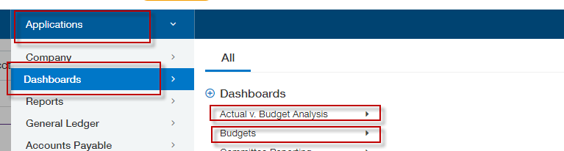
- Use filters so that the reports within the dashboard contain the information you are looking for.
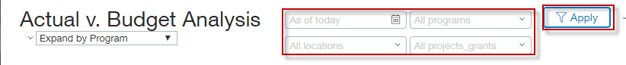
- This table summarizes some common analyses that you might wish to perform:
I want to… | Dashboard / Instructions
Review my actual results against budget for a specified period of time | Actual vs. Budget Analysis > Expand by Program, Location, or Location-MTCA, using a filter for the proper date, location, and program
Investigate why I have a variance against budget in a specific GL account | Actual vs. Budget Analysis > Expand by Program, Location, or Location-MTCA, using a filter for the proper date, location, and program. Drill down into the specific financial statement line or account # to see a listing of the transactions posted that make up the total balance.
See my approved budget for this fiscal year | Budgets > Approved Budgets (be sure to use a 6/30/20XX date filter so you see the proper fiscal year budget)
Use dashboards and reports to help me prepare my budget for the upcoming year | Budgets > Budget Preparer

Financial Report Terminology
- FYTD = Fiscal year to date. Our fiscal year runs from 7/1 through 6/30, so a FYTD report will give you results from 7/1 through the ‘as of date’ in your dashboard filter.
- QTD = Quarter to date. Our quarters run from 7/1 to 9/30, 10/1 to 12/31, 1/1 to 3/31, and 4/1 to 6/30. A QTD report will give you results from the beginning of a quarter through the ‘as of date’ in your dashboard filter. For example, a 2/28/20 date in your filter will yield results from 1/1/20 through 2/28/20. Or, a 9/15/19 date in your filter will yield results from 7/1/19 through 9/15/19.
- FS = Financial Statement
- GL = General Ledger
- AP = Accounts Payable
- AR = Accounts Receivable

Accessing the Dashboards Module
- To access the Dashboards Module, Select ‘Applications’ from the top left corner of your screen.
- Select ‘Dashboards’ from the drop-down menu that opens up, then select a dashboard group. Currently, we have two primary dashboard groups, each of which contains multiple dashboards depending on the type of information you are seeking.
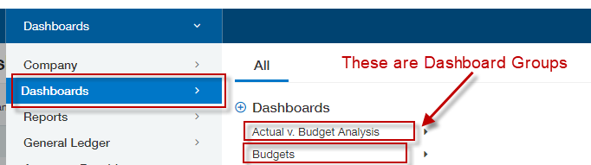
- Each Dashboard Group has multiple dashboards within it. Clicking on the Dashboard Group will show you the individual dashboard options. Each individual dashboard contains multiple financial reports. Below is a screen shot showing an example of the Actual v. Budget Analysis dashboards that are presently available.
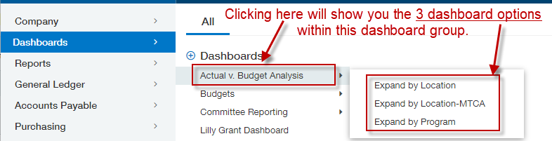

Dashboard Filters
- Dashboard filters determine the information that is used to populate the reports within each dashboard. Using dashboard filters properly is CRITICAL to having meaningful and accurate information in your reports. The filters are shown in the top right corner of your dashboard. Be sure to click ‘Apply’ after entering your filters. If you see the word ‘Apply’, then your filters haven’t yet been applied.
  - Date. The default date is today’s date, which means the financial report will show actual results through today and a pro-rated budget through today. For example, if the date filter is set to 9/15/2019, the budgeted amount for each account will include the full July budget, full August budget, and 50% of the September budget.
  - Program. The default program filter is to show all programs that a user has access to. You MUST select a specific program or group of programs in order for the dashboard reports to work properly. A reminder that Catholic Center employees have access to program 1102 Professional Development in addition to all of the programs that are relevant to their respective areas. Failing to filter on a specific program or group of programs will result in inclusion of 1102 Professional Development.
  - Location. The default location filter is to show all locations that a user has access to. You MUST select a specific location or group of locations in order for the dashboard reports to populate with information. An error message will show up if you don’t select a specific location or group of locations.

  - Project_Grant. The default project_grant filter is all project_grants (these aren’t restricted by user, so you will see all). Typically, this field will be left to show ‘All projects_grants’; however, you can filter on a specific project_grant if that information is useful.
- Question: When using filters, why do I see groups first followed by individual dimensions (Locations, Programs, and Project_Grants)? What are the groups for?
  - Answer: OAS has created a series of dimension groups for Locations and Programs, as well as some for Project_Grants (less common). If the individual locations or programs you have access to are included in one of the dimension groups, you will see that dimension group show up as an option when filtering. Dimension Groups are alpha text only and do not include any numbers; whereas individual dimension (locations or programs) are preceded by the numeric dimension ID and then the dimension name. Dimension groups are useful when you want to see multiple locations or multiple programs within the same report.
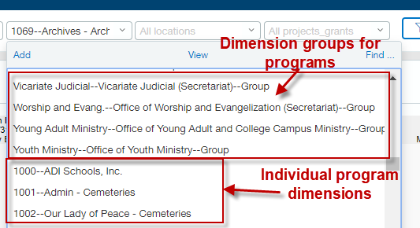

Drilling Down on Reports
- When viewing reports in the browser (i.e. not PDF or Excel), Intacct allows users to drill down from summary amounts to the detailed transactions.
- Any figures or text in blue are hyperlinks that can be clicked on to “drill down” to the next level of detail. The drill down hierarchy is as follows:
  - Financial statement line item drills down to…
  - Listing of accounts included in the financial statement line item, which drills down to…
  - General ledger transactional activity report for the account selected, which drills down to…
  - AP Bill, AR Invoice, General Journal Entry, among other types of individual transactions.
- Important rule: When given the option to click on a link for an amount (vs. a description or account name), ALWAYS click the amount.
- Below is a screenshot showing what a financial report looks like that is presented at a FS (Financial Statement) level.
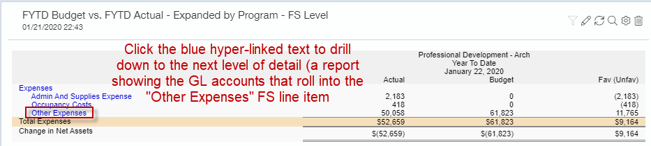
- Clicking on the Financial Statement Line Item Other Expenses takes you to the following screen (see below). This view is a listing of the accounts and balances included in the Other Expenses financial statement line.
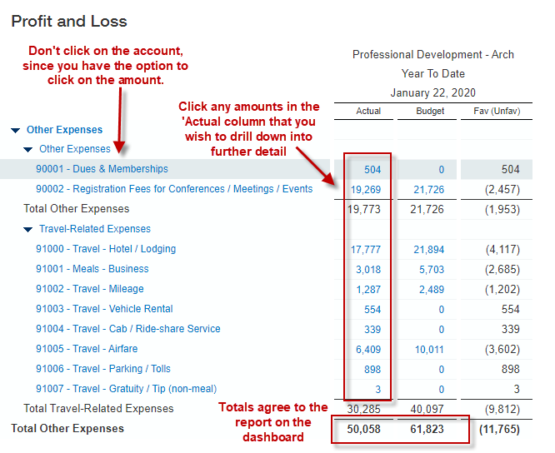
- To drill down further, click on the link for $19,269 for 90002 Registration Fees for Conferences Meetings and Events, which will take you to the general ledger report for the 90002 Registration Fees for Conferences Meetings and Events account. The general ledger report consists of transaction-level detail for an account, totaling the $19,269 expense.
- Important: The first time you access a general ledger report, you’ll need to customize your settings for how you view general ledger reports. Click ‘Customize’ in the top right corner of the General Ledger Report and edit your settings to match the screen shot below. These General Ledger Report settings are “sticky”, which means Intacct will remember your settings for future general ledger reports you run.
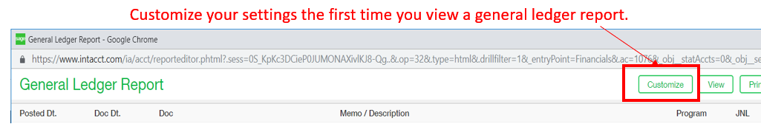
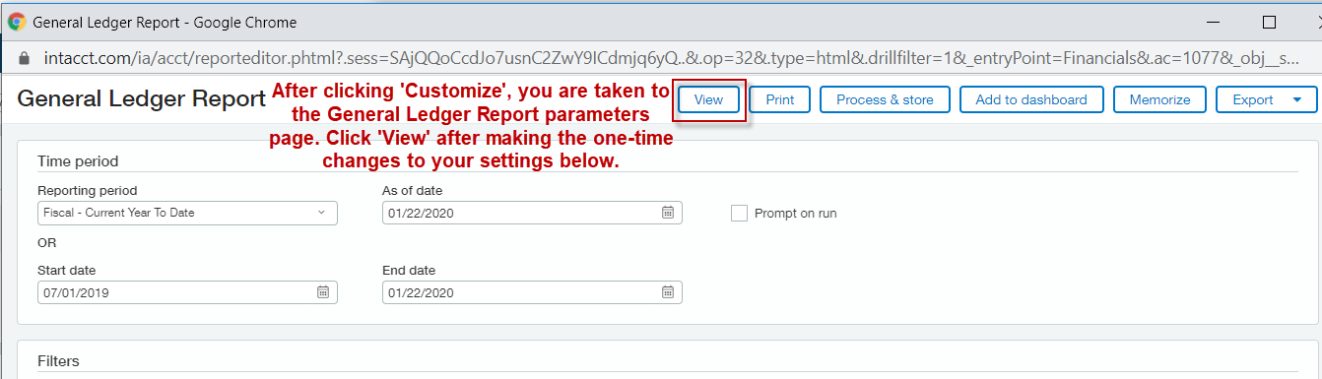
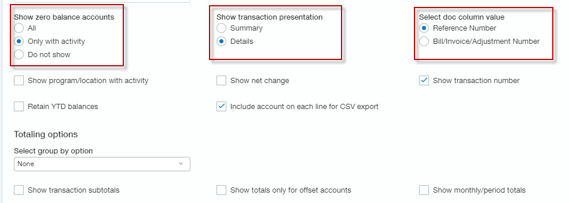
- The screen shot below is part of the General Ledger Report for 90002 Registration Fees for Conferences/Meetings/Events. The blue text for the amount (debit/credit) can be clicked on to drill down to the AP Bill.
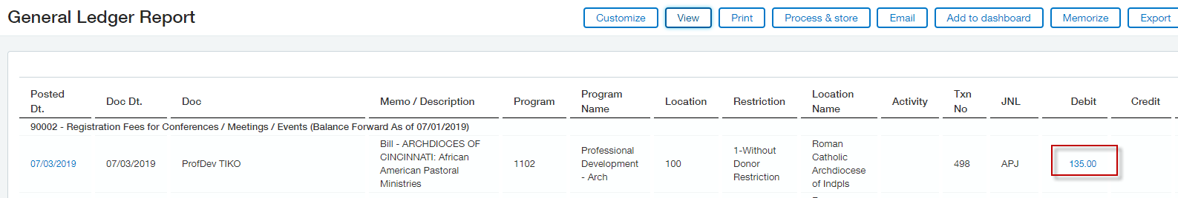
- The Accounts Payable bill (see below) contains all relevant information for the transaction, including the check #, date paid, and the attachment (invoice) associated with the expense.
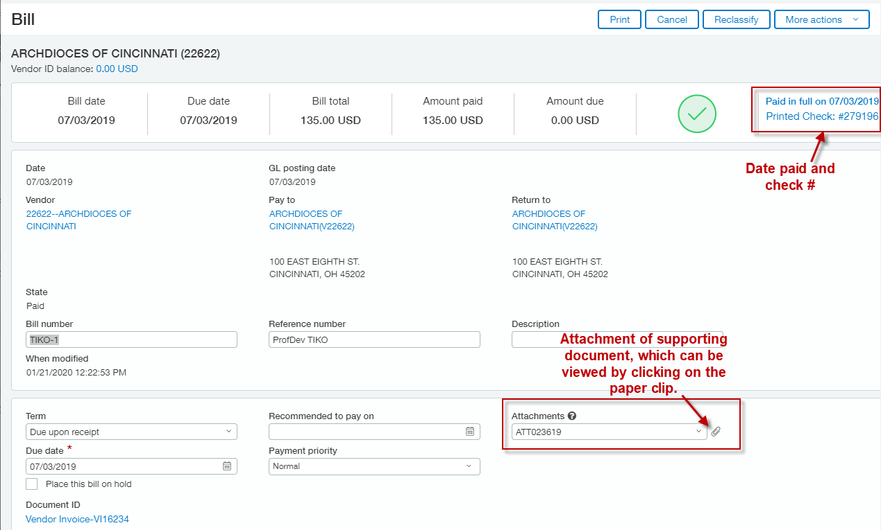
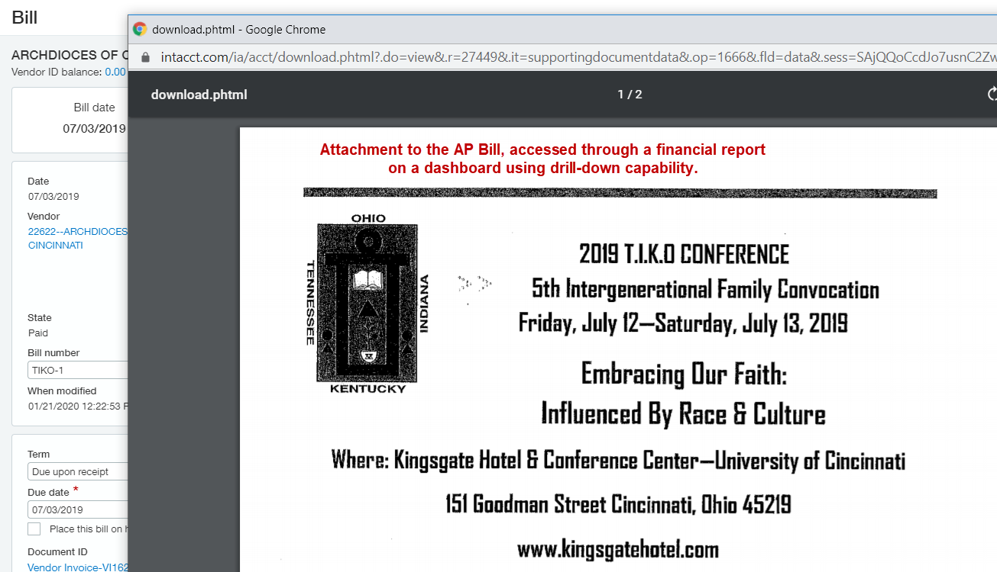

Exporting Reports to Excel
- You can easily export reports from Dashboards into Excel format.
- Click on the magnifying glass in the top-right corner of the report you wish to export.
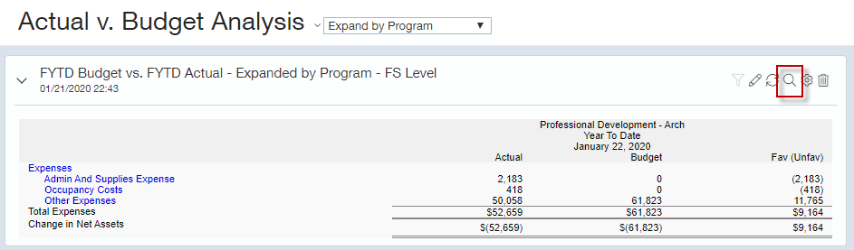
- Typically, this will cause the report to open in a separate tab.
- Verify that the totals from the report match the totals in the dashboard. If they do, move on to the next step. If not, read below.
  - Totals don’t match: In some instances, the filters from the dashboard won’t carry over to the newly-opened report, which will result in different amounts showing up. To correct this, you’ll just need to re-filter the newly-opened report (follow the screen shots below).
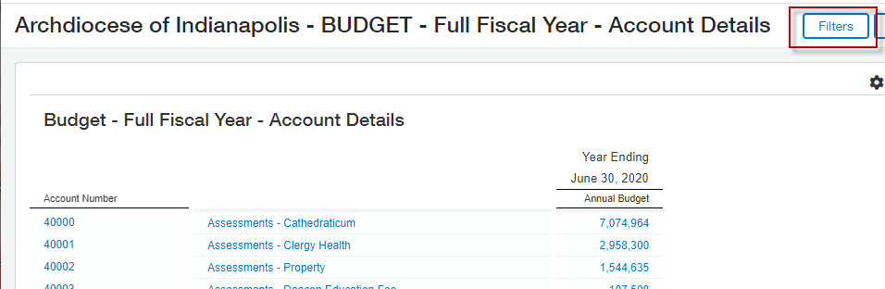
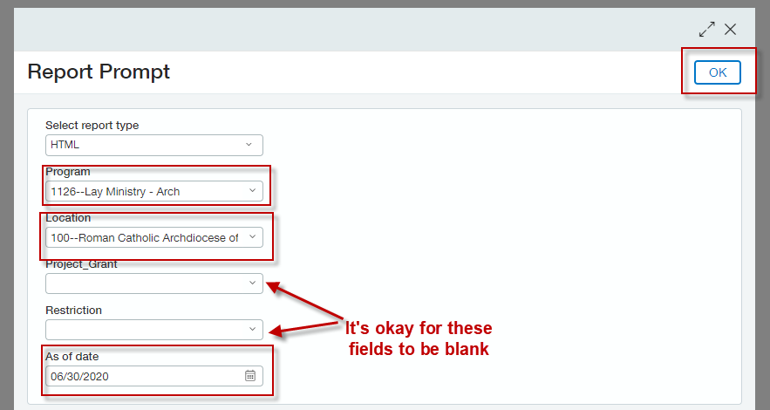
- Once you’ve confirmed that the newly-opened report contains the information you want and totals match back to the Dashboards screen, you can click on ‘Excel’ in the top right corner to generate the report in Excel.
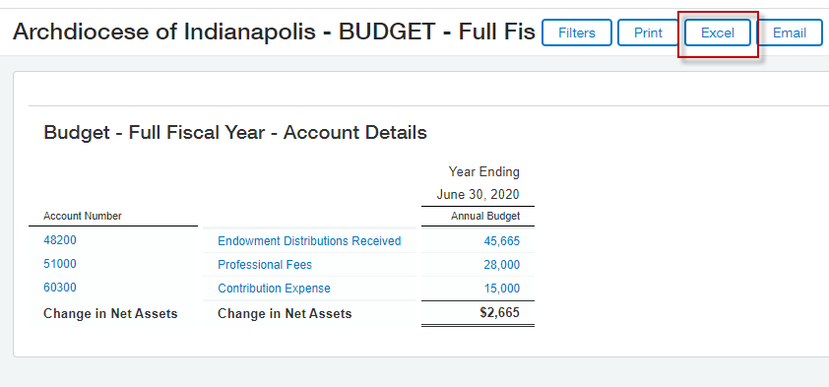

General Ledger Report
- The reports in the Dashboards and Reports modules are typically financial statement reports. If you want to view a transaction detail report, you should run the General Ledger Report. General Ledger Reports can be filtered on all dimensions (Location, Program, Account, Project_Grant, Vendor, Customer, Activity, Restriction) and are one of the most flexible reports to use in Intacct. Below is an example of what the General Ledger Report looks like:
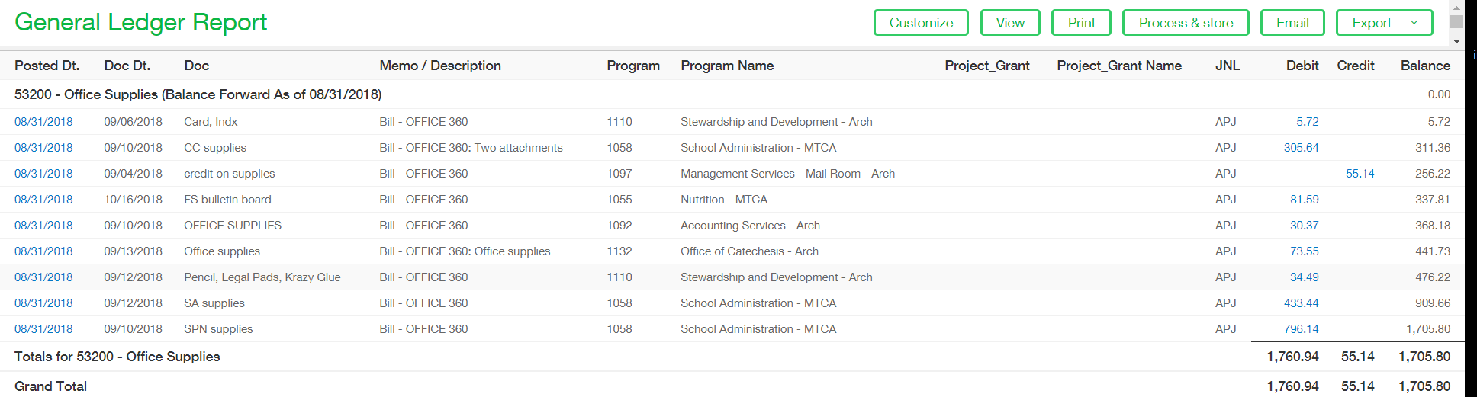
- To run the General Ledger Report, go to the General Ledger module and click on ‘General Ledger’ under the reports module on the far right side of the menu.
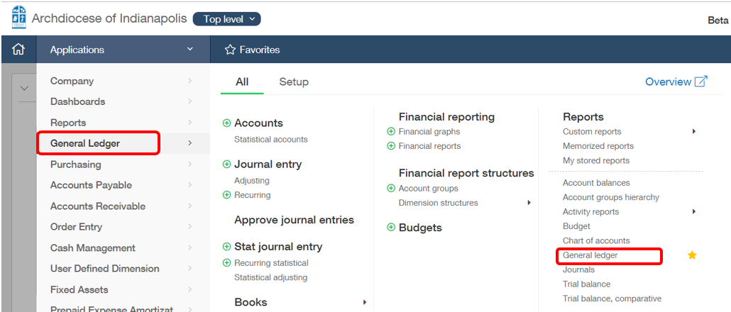
- Time Period
  - Reporting Period – If a reporting period says ‘to date’, then it will go through the specific ‘As of Date’ indicated.
    - Current Month – provides activity for the entire current month, regardless of the day in the ‘As of Date’ field. An as of date of July 15, 2018 yields the same result as an as of date of July 31, 2018, which is all of July’s activity.
    - Current Month To Date - provides activity for the current month through the date in the ‘As of Date’ field. An as of date of July 15, 2018 yields activity for the first 15 days of July, vs. an as of date of July 31, 2018 which yields activity for the entire month of July.
  - Start Date and End Date – define a specific start date and end date for your report.
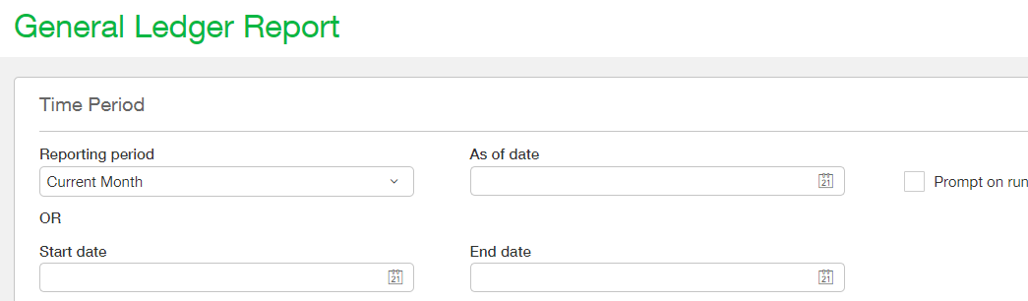
- Filters
  - GL Accounts – You can select a range of accounts, a single account, or all accounts.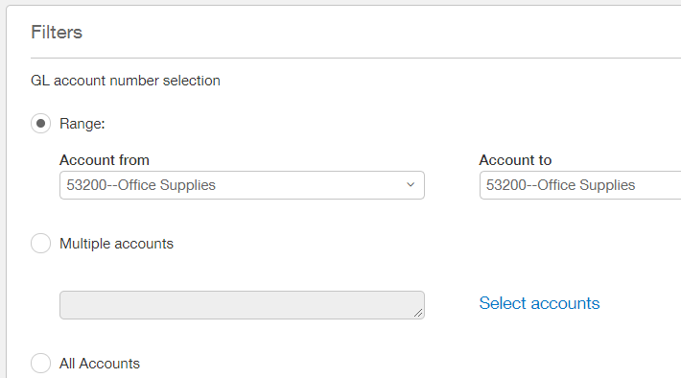
  - Dimension Filters: Program, Location, Project_Grant, Customer, Vendor, etc. You can select a specific dimension to filter the report by. For example, to see a report of all activity within Chancery Operations, you would select 1071 – Chancery Operations in the Program filter.
- Format
  - You can also select which Dimension Values are displayed on the report. This does not impact the filtering of the report, it just impacts what columns are included in the report. Recommended practice is to definitely include the Program ID and Program Name, and optionally include the Project_Grant ID, and Project_Grant Name. These are also ‘sticky’ settings.
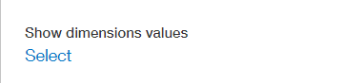
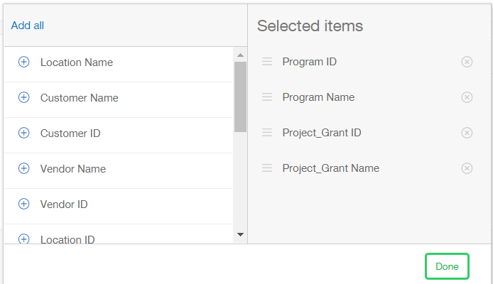
  - Sticky Settings. These General Ledger Report settings are “sticky”, which means Intacct will remember your settings for future general ledger reports you run. We recommend using the following settings:
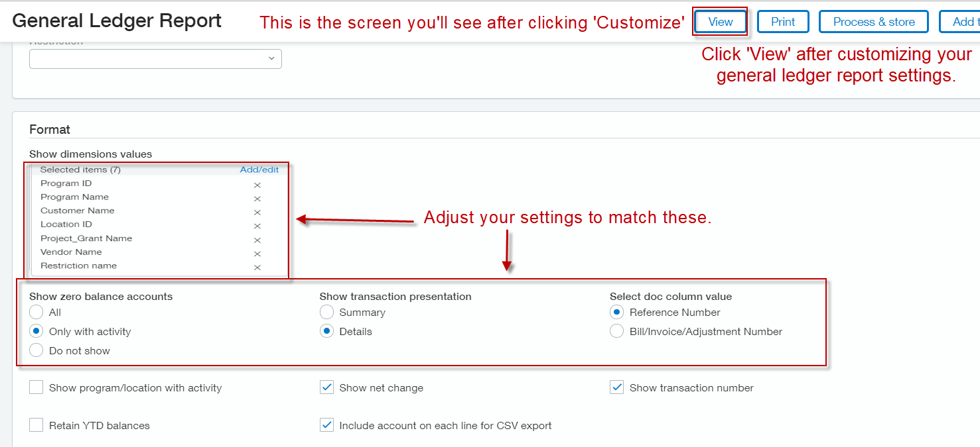
- When finished selecting your parameters for the report, click ‘View’ in the top right corner. From here, you can also export the report into PDF or Excel.
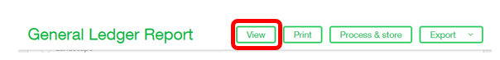
- If the report isn’t quite what you expected, you can revise the report by clicking ‘Customize’ in the top right corner. The parameters will still be there and can be adjusted by you as you see fit.
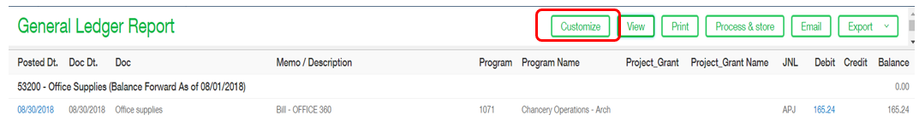

Accounting Policies
- Basis of accounting
  - The books and records of the Archdiocese and the agencies in its combined financial statements are maintained using accrual-basis accounting and follow accounting principles generally accepted in the United States of America (US GAAP).
- Fundraising Events (47XXX)
  - All entries to a Fundraising Events account should also be coded to a project_grant associated with the specific event.
  - Which events should use the 47XXX accounts?
  - https://www.edelsteincpa.com/part-2-best-practices-in-nonprofit-special-events-reporting-guidelines-to-increase-clarity-and-consistency/
- All Mission Office (program 1079) contributions should be coded to a specific Mission Office project_grant.
- CYO Program Fee Revenue for its Athletics programs should also be coded with an Activity dimension to identify the specific grade level for the revenue. This is not required on the expense side of things (e.g. officials payments only need to be coded to Basketball Program, not to the specific grade-level Activity).
- All transactiosn require a restriction
- Expenses should only be without donor restriction.
- All revenues with donor restriction should be coded with a project_grant ID.
- All Lilly Grant (program 1088) transactions should be coded with a project_grant ID.

